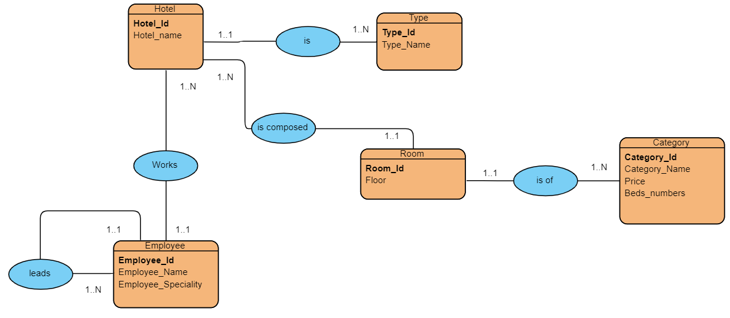

Convertir en modèle relationnel

### Hotel( **Hotel_Id**, Hotel_name, **#Type_Id**)

* Type (**Type_Id**, Type_Name)
* Category(**Category_Id**, Category_Name, Price, Beds_Numbers)
* Room (**Room_Id**, Floor, #**Category_Id, #hotel_Id )**
* Employee (**Employee_Id**, Employee_Name, Employee_Speciality, **#Hotel_Id**)
* Reservation (**Reservation_Id, #Room_Id, #Customer_Id** , Check_In_Date, Check_Out_Date)